NASA’s Deep Impact Mission: Eyes on the Skies

Comet Comparisons

ACTIVITY SHEET

Observe this image of Comet Machholz

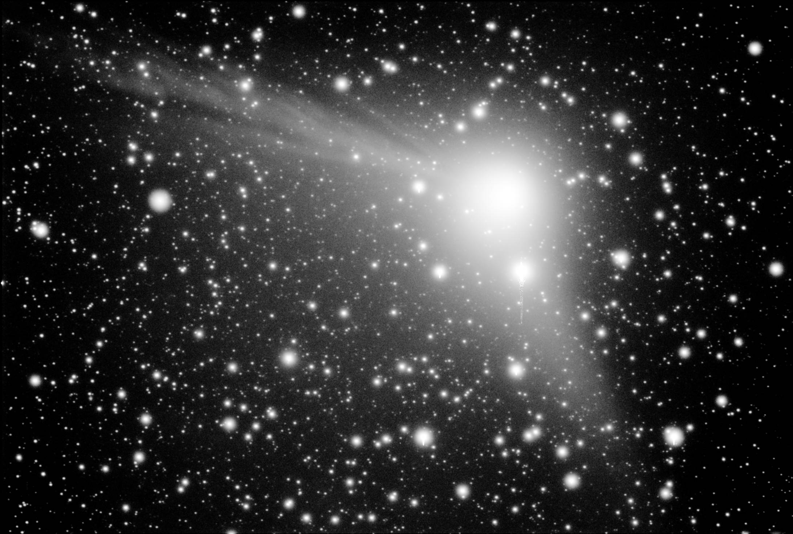

Comet Machholz. This image is a 6 minute exposure at 05:00 U.T. taken on January 2, 2005 taken with a 7.5 cm telescope.

Write a description of this comet based on your own observations.

Read the following descriptions of this comet from three different astronomers.
Astronomer 1:
Comet Machholz. This image is a 6 minute exposure at 05:00 U.T. taken on January 2, 2005. As you’re looking at this image, north is up and west is to the right. The width is about 3 degrees and the height about 2 degrees. The camera is a 3” aperture, f/4.0. This image of Machholz shows the two constituents of a comet’s coma, the ion tail extending up to the left in the anti-solar direction and the dust cloud and tail extending down and slightly to the right that was blown off the comet many days previously.

Astronomer 2:
This image of Comet Machholz was taken by Gary Emerson. It is a 6 minute exposure taken at 05:00 U.T. on January 2, 2005. As you’re looking at this image, North is up and West is to the right. The width is about 3 degrees and the height about 2 degrees. The image was taken with a 7.5 cm telescope with a 30 cm focal length (f/4=focal length/aperture). The comet dominates the image presented here and the background stars can be seen through the coma. The extent of this coma is about 1.8 degrees East-West and about 1.6 degrees North-South. The coma has a condensation and there are two jet-like structures seen. One is at ~70 degrees East of North and linear in its bright streaks and has dark lanes in it. The second is at ~60 degrees South of West and has less structure than the first one. The space between the two jets could be described as a broad and diffuse fan.

Astronomer 3:
This is a very interesting picture of comet Machholz. The comet is quite obvious against the backdrop of stars. The coma is nearly 30 arcminutes across (that is about the width of the full Moon) but stars can still be seen through the diffuse cloud of dust and gas! There are also two extensions from the coma - the two tails of the comet. The ion/gas/plasma tail points off to the left while the dust tail points down in the image. The dust tail is less defined than the gas tail. It is interesting to note that the tails appear to be pointing in different directions. The gas tail always points away from the sun, so we can deduce that the sun is somewhere in the direction off the right side of the image. But figuring out the exact geometry is difficult because it is hard to tell if the tails are just short or appear to be short because they may also be pointing roughly away from us.

Read the descriptions a second time. This time look for details that are in two or more of the descriptions. On the next page you will be completing a Venn diagram in order to compare and contrast the descriptions from these three astronomers.

Comet Machholz

Let’s try the same procedure, but this time with Comet Tempel 1.
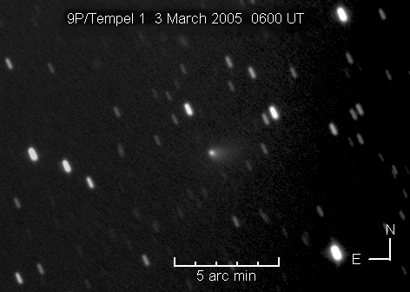

Write a description of this comet based on your own observations.

Read the following descriptions of this comet from two different astronomers.

Astronomer 2:
This is an image of comet Tempel 1 taken by Dennis Persyk at Igloo Observatory, Hampshire, IL.
The images represents a total of 120 minutes exposure time taken in 4 to 6 minute subframes at 6:00 UT on March 3, 2005. In this image, the telescope was tracking at the rate of motion of the comet, therefore, the background stars are seen as elongated streaks or blobs. The comet is located approximately in the middle of the frame and is seen as a bright circular condensation (circular relative to the trailing stars) with a diffuse fan-shaped coma extending almost due West. The coma extends more than 1.5 arcseconds west and about 1 arcsecond North-South. The central condensation is about 1/4 arcsecond across, which seems to be about the size of the images of stars, hence it is the seeing limit of this observing night.

Astronomer 3:
This image of Tempel 1 shows a stellar-like coma and just the barest hint of a dust tail pointing off to the right. The image was stacked on the comet so the stars appear streaked.

Read the descriptions a second time. Then, use the Venn diagram below to compare and contrast the descriptions from these two astronomers.

Comet Tempel 1

