 | AAS 03-026

Deep Impact Flyby Spacecraft Instrument Pointing in the Presence of an Inactive Impactor Spacecraft

Daniel G. Kubitschek, Nick Mastrodemos, and Stephen P. Synnott

Jet Propulsion Laboratory
California Institute of Technology

26th ANNUAL AAS GUIDANCE AND CONTROL CONFERENCE

February 5-9, 2003 Sponsored by
Breckenridge, Colorado Rocky Mountain Section



AAS Publications Office, P.O. Box 28130 - San Diego, California 92198

AAS 03-026

DEEP IMPACT FLYBY SPACECRAFT INSTRUMENT POINTING IN THE PRESENCE OF AN INACTIVE IMPACTOR SPACECRAFT

Daniel G. Kubitschek, Nick Mastrodemos, and Stephen P. Synnott

Jet Propulsion Laboratory

California Institute of Technology

The engineering goal of the Deep Impact mission is to impact comet Tempel 1 on July 4, 2005, with a 350 kg active Impactor spacecraft (s/c). The relative velocity will be just over 10 km/s. The impact is expected to excavate a crater of approximately 20 m deep and 100 m wide. The science objective is that of exposing the interior material and understanding the properties of the nucleus. In order to achieve the engineering goal and science objective, Deep Impact will use the autonomous optical navigation (AutoNav) software system to guide the Impactor s/c to Tempel 1 intercept near the center of brightness (CB), while a second s/c, the Flyby s/c, uses identical software to determine its comet-relative trajectory providing the attitude determination and control system (ADCS) with the relative position information necessary to point the High Resolution Instrument (HRI) and Medium Resolution Instrument (MRI) at the expected impact site during encounter.

If the Impactor s/c is determined to be functioning improperly prior to release, the issue of predicting the impact location to correctly point the instruments at key science epochs (TOI: Time of Impact; and TOFI: Time of Final Imaging), becomes important and therefore must be studied. This relies, fundamentally, on the ability to determine the trajectory of the Impactor s/c relative to the Flyby s/c by treating the Impactor s/c as an optical beacon, relative to which the Flyby s/c’s trajectory is estimated using images of the Impactor s/c. Simulation results show that for an inactive Impactor s/c, the pointing error is improved from 519 μrad (1 μrad = 10⁻⁶ radians) to 72.3 μrad (3σ) at TOI, and from 3.96 mrad (1 mrad = 10⁻³ radians) to 441 μrad (3σ) at TOFI. When compared to the baseline CB targeting/tracking approach, results show the pointing error contribution due to knowledge of the impact location changes from 60 μrad to 72.3 μrad (3σ) at TOI, and from 495 μrad to 441 μrad (3σ) at TOFI. This paper deals only with the pointing error contribution due to errors in predicting the impact location and describes the acquisition of optical data of the Impactor s/c and associated errors using the Flyby instruments; the expected uncertainty in predicting the impact location and the resulting pointing errors; and the algorithm for autonomously computing a pointing correction during encounter.

INTRODUCTION

The engineering goal of the Deep Impact mission is to impact comet Tempel 1 on July 4, 2005, with a 350 kg active Impactor spacecraft (s/c). The impact velocity will be just over 10 km/s. The impact is expected to excavate a crater of approximately 20 m deep and 100 m wide. A second spacecraft, the Flyby s/c, is responsible for delivering the Impactor s/c and will perform a slowing maneuver (deflection maneuver), following Impactor release, to observe the impact event, ejecta plume expansion, and crater formation, which will take place over a period of approximately 800 seconds. Figure 1 shows the flight system configuration with the Impactor s/c stowed in the lower portion of the Flyby structure. Figure 2 shows the encounter geometry for the Deep Impact mission. The science objective is that of exposing the interior material and understanding the properties of the nucleus.
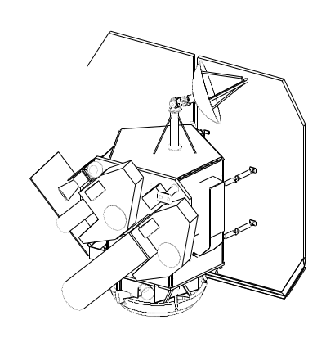
HRI
MRI
ITS Boresight
X_{sc}
Y_{sc}
Z_{sc}

Figure 1 Deep Impact flight system configuration showing the instrument platform, High Gain Antenna, ITS boresight and solar array² 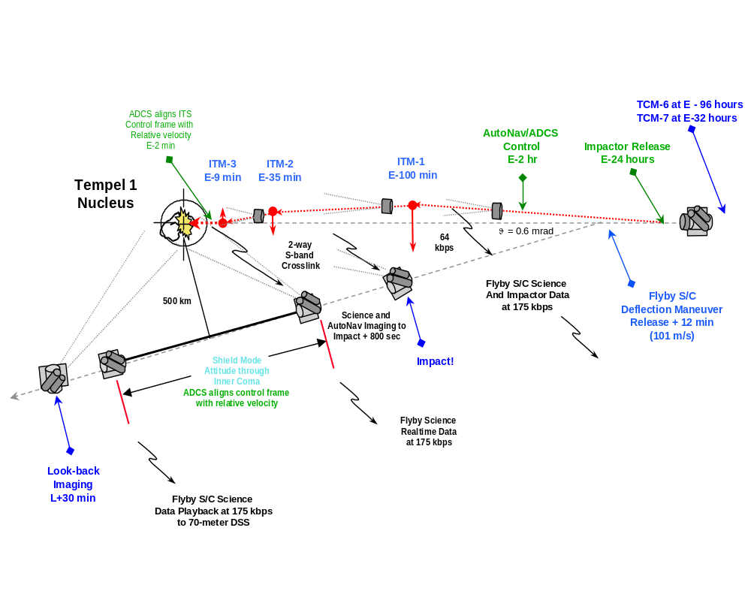
Figure 2 Tempel 1 encounter geometry for the Deep Impact mission

Deep Impact will use the on-board autonomous optical navigation (AutoNav) software system¹ to guide the Impactor s/c to Tempel 1 intercept near the center of brightness (CB). The Flyby s/c uses identical software to determine its comet-relative trajectory in order to provide the attitude determination and control system (ADCS) with the relative position information necessary to point the High Resolution Instrument (HRI) and Medium Resolution Instrument (MRI) at the nucleus CB during encounter. The Impactor s/c and the Flyby s/c operate in an independent fashion with the Flyby s/c pointing the MRI/HRI instruments at the impact site in an indirect way by assuming that the Impactor s/c will impact at or near the nucleus CB. Figures 3 and 4 show simulated images of the comet nucleus using the Impactor ITS camera and the Flyby MRI/HRI cameras along their respective trajectories.

ITS at E-2hrs ITS at E-5 min
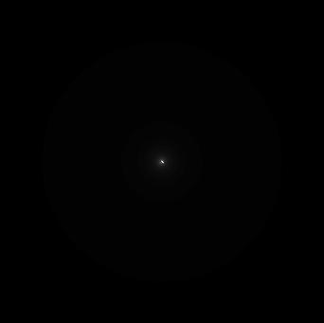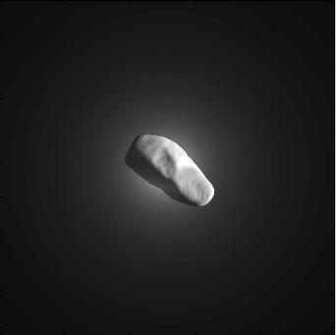

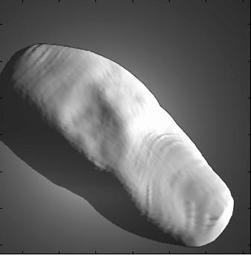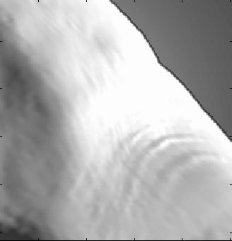
ITS at E-1 min ITS at E-30 sec

Figure 3 Simulated ITS images of the comet nucleus (based on Halley-Stooke data) during encounter where E- designates time to impact

MRI at E-2 hrs MRI at E-0 sec MRI at E+800 sec
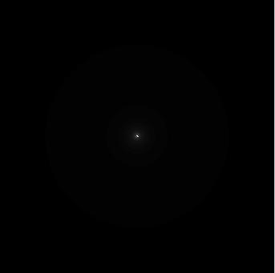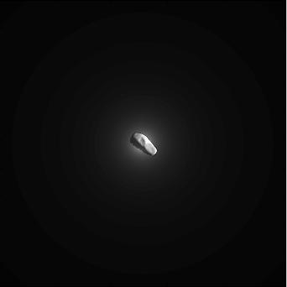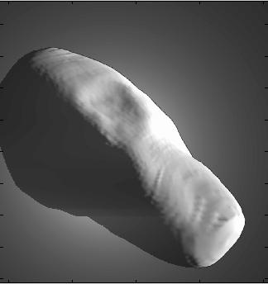

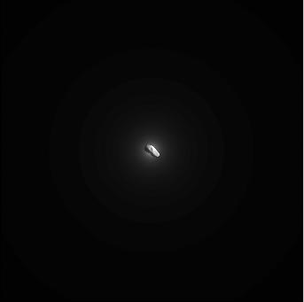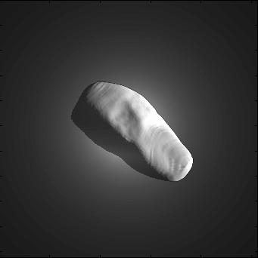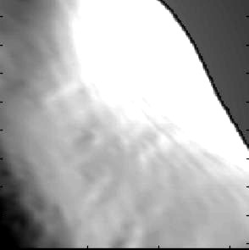
HRI at E-2 hrs HRI at E-0 sec HRI at E+800 sec

Figure 4 Simulated MRI and HRI images of the comet nucleus (based on Halley-Stooke data) during encounter where E- designates time to impact. Note the apparent rotation of the nucleus, seen in the MRI images, as the Flyby s/c passes underneath

Two key science epochs drive system performance during the Tempel 1 encounter: Time of impact (TOI), and Time of final crater imaging (TOFI). To obtain the highest possible temporal resolution imaging at the TOI, the HRI will be operated in a 128x128 pixel sub-frame mode (see figure 5) which allows images to be taken more rapidly than if they were full-frame exposures. The HRI instrument has a 1008x1008 active pixel charged-couple device (CCD) detector with a pixel scale of 2 μrad/pixel (1 μrad = 10⁻⁶ radians), giving it a 2 mrad (1 mrad = 10⁻³ radians) field-of-view (FOV). Therefore, overall pointing error must not exceed 128 μrad at TOI in order to capture the impact event in the HRI 128x128 pixel sub-frame. At the time of final imaging, the Flyby s/c will be at a range of 700 – 1000 km from the surface of the nucleus. At this range, the HRI FOV covers only a small portion of the nucleus (mean nucleus radius is estimated to be 2.6 km with an approximate axial ratio of no larger than 2:1). Pointing at both of these science epochs requires good knowledge of the impact site relative to the observed CB. Analysis shows that for an active Impactor maneuvering to intercept the CB, pointing at TOI, to capture the impact site in the 128x128 pixel subframe, is achievable and less than 100 μrad (3σ) of which 60 μrad (3σ) are due to uncertainties in knowledge of the actual impact site location. Studies have shown that the probability of capturing a high-resolution image of the fully developed crater is 97% for the expected HRI instrument performance³.

Due to the short lifetime requirement (7 days) of the non-redundant Impactor s/c, the inactive Impactor failure scenario has warranted attention. There are a number of considerations that must be addressed under this contingency, broadly divided into two aspects: 1) achieving impact in an illuminated area with an inactive Impactor s/c; and 2) autonomously predicting the impact location of the inactive Impactor s/c to compute and apply a pointing correction relative to the CB in an effort to minimize Flyby pointing performance degradation at the key science epochs. The first problem is addressed by fine-tuning the trajectory of the flight system to intercept the nucleus of Tempel 1 prior to the release of the Impactor s/c. If it is determined that the Impactor s/c is not in an operational condition prior to release, then the maneuver to fine-tune the trajectory will be delayed to allow for additional optical navigation data collection and the release of the Impactor will be postponed to E-12 hrs to increase the probability of an illuminated impact. Here we discuss the method for solving the second problem. I

If we consider only the contribution of errors in knowledge of the impact site location, the baseline targeting and tracking approach provides TOI and TOFI pointing performance as shown in table 1. In addition, table 1 shows that for an inactive Impactor s/c our ability to point the Flyby s/c instruments is substantially degraded due to uncertainties in knowledge of where the impact will occur relative to the nucleus center of brightness as observed from the Flyby s/c during the last 2 hrs of the encounter. The results shown in table 1 for a maneuvering Impactor s/c are only part of a larger pointing error budget and must be combined, in a root-sum-square (RSS) sense with errors such as knowledge of the Flyby s/c’s position relative to the observed CB, motion of the CB due to nucleus rotation, ADCS alignment errors, ADCS alignment drifts, and ADCS control errors to arrive at the total pointing error at TOI and TOFI.

Table 1
Expected Flyby s/c pointing errors due to impact site location uncertainties at TOI and TOFI for the baseline targeting/tracking approach and for the current inactive
Impactor s/c scenario

Approach | TOI Pointing 3σ Error  (μrad) | TOFI Pointing 3σ Error  (μrad)
Baseline  (Maneuvering Impactor) | 60 | 495
Inactive Impactor | 519 | 3960

HRI FOV
512x512
HRI subframe
128x128
HRI subframe

Figure 5 MRI image at TOI showing the HRI FOV (blue), the 512x512 pixel HRI subframe (green) and the 128x128 pixel HRI subframe (red) within which the impact site must reside at TOI

IMPACT SITE PREDICTION FOR AN INACTIVE IMPACTOR

The basic problem with an inactive Impactor s/c is that it cannot maneuver itself to impact at a location that is expected, independently, by Flyby s/c. Although the Impactor s/c has a high likelihood of impacting somewhere on the surface (studies show ~ 95% probability of delivering an inactive Impactor on an impact trajectory³), pointing the narrow FOV HRI instrument with the Flyby s/c is degraded: the Flyby s/c will point at the CB which may be as much as 4.5 km (3σ) from the actual impact site; an approach that may only capture crater images with the wider FOV MRI instrument (7 m resolution) instead of capturing images with the desired spatial resolution (3.4 m) obtained using the HRI instrument.

The basic idea of impact site prediction relies on the fact that following release, the inactive Impactor’s trajectory remains unperturbed until impact. The Flyby s/c will initiate a deflection maneuver which is designed to control the Flyby miss-distance to 500 ± 50 km and slow the Flyby spacecraft to provide 800 ± 20 seconds of science imaging from the time of impact to the time of shield mode entry prior to passage through the inner coma dust environment (shield mode occurs approximately 50 sec before the Flyby s/c reaches it’s closest approach point). If the Impactor s/c is healthy, then the deflection maneuver will nominally take place at E-23:48 hrs (12 min after Impactor release), where E- designates time of impact, and will be ~ 102 m/s in magnitude. This maneuver results in execution errors that map to a 32 km B-plane position error (3σ) at encounter and an 8 sec (3σ) time-of-flight (TOF) error.

The orthogonal triad that represents the orientation of the B-plane coordinate system relative to the International Celestial Reference Frame (ICRF), as seen in figure 6, is determined as follows:

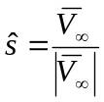

Here, 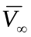 is the comet-relative velocity in the inertial frame of reference. The unit vector,, is derived by rotating by and angle of -90° about the ICRFaxis, projecting the result onto the equatorial plane, and normalizing (The unit vector is always in the ICRF x-y plane).

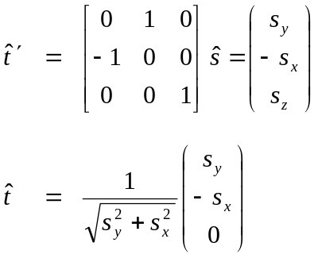

And finally,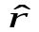is the cross product of and .

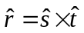.

The transformation from ICRF to B-plane coordinates is given by:

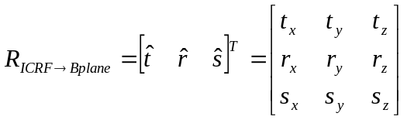.

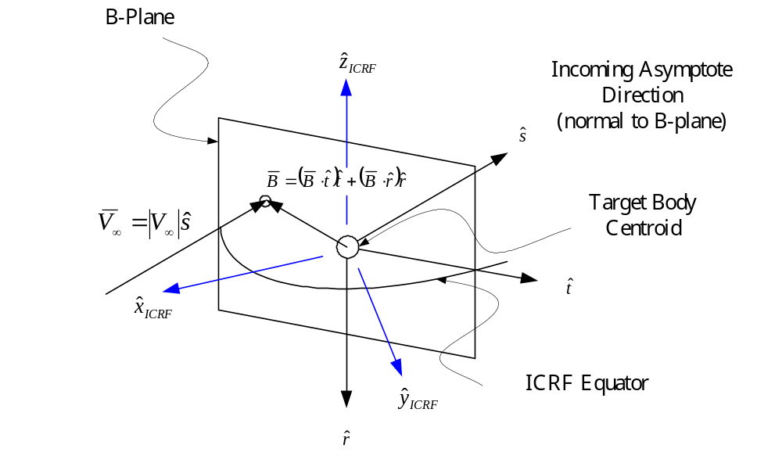

Figure 6 Definition and orientation of the B-plane relative to the International Celestial Reference Frame (ICRF)

If, following the deflection maneuver, the trajectory of the Flyby s/c can be estimated relative to that of the Impactor, then the Flyby’s trajectory can be integrated and its position evaluated relative to the Impactor s/c at TOI. The key is to treat the Impactor as an optical beacon, relative to which the Flyby s/c’s trajectory may be estimated using optical images of the Impactor. The expectation is that these images will provide very accurate determination of the Flyby’s trajectory crosstrack to the line-of-sight relative to the Impactor. Alongtrack information will come primarily from radiometric tracking of the Flyby (range and Doppler measurements). This post-deflection radio tracking is part of the baseline approach and serves to evaluate the need for a contingent deflection trim maneuver, at E-12 hrs, as well as to reduce the TOF error introduced by the deflection burn. A summary of the post-deflection Flyby navigation plan is as follows:

- Continue radio tracking of the Flyby s/c for 6 hrs after end of deflection burn
- Image the Impactor from the Flyby, beginning 35 minutes after release
- Estimate the Flyby’s heliocentric trajectory with a radio-only solution
- Estimate the Flyby’s Impactor-relative trajectory with an optical solution using initial conditions obtained from the radio-only solution

OBSERVING THE IMPACTOR SPACECRAFT

Following separation, the Impactor remains on a trajectory, which is essentially the incoming asymptote relative to comet Tempel 1. The Flyby s/c slows by ~ 101 m/s with an ~ 5.7 m/s velocity component perpendicular to the incoming asymptote, giving a constant inertial view angle of the Impactor from the Flyby s/c of ~ 3° with respect to the Impactor’s comet-relative trajectory. This angle does not change until impact. Images of the Impactor and background stars will be acquired, beginning 35 minutes after release, and processed on the ground. The accuracy of the orbit determination based on these optical data depends, among other things, on the Signal-to-Noise Ratio (SNR) of the background stars and the observability of the Impactor s/c using the Flyby instruments.

Impactor Spacecraft Surface Properties

The Impactor has an irregular shape and a mix of materials with varying reflective properties, e.g. metal, paint, thermal blanket etc. The ITS anti-boresight side of the Impactor s/c bus, the one that for most of the time will be facing the Flyby s/c, has a hexagonal shape (figure 7). The ITS boresight direction has a hemispherical shape made up of copper plates, with six panels connecting the two sides. An accurate determination of the optical signal strength obtained from the Impactor at a given orientation would require knowledge of the reflective properties, exact shape modeling and attitude history. The Impactor, during the time it is imaged from the Flyby, may be turning to point the ITS off-nucleus to obtain calibration images, or in the case that it is inactive it will be tumbling at an unknown rate and direction. The overall phase darkening of the Impactor at different attitudes will vary in a complicated way, requiring a modeling process beyond the scope of a contingency treatment. The approach is not to compute the exact signal from the Impactor, but rather to establish whether reasonable, as well as conservative assumptions, result in a sufficient SNR.

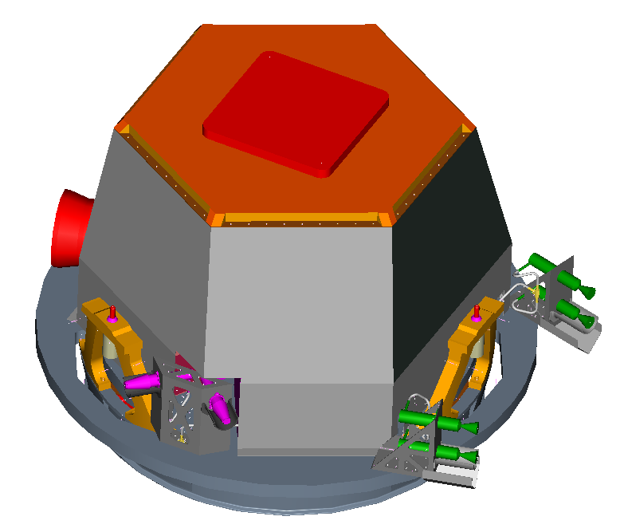
ITS Boresight

Figure 7 Impactor s/c flight system configuration⁴

Our simplified assumption is an irregular shape with an average diameter of 0.8 m and albedo of ~ 0.3 based on drawings and data from Ball Aerospace Technologies Corporation (BATC). Assuming that we view mostly a flat Impactor surface and that the single particles on the surface scatter isotropically, we may adopt a Lommel-Seeliger reflection law with an average incidence angle, i, equal to the phase angle ≈ 65°; and an average emission angle, e, equal to the view angle from the Flyby s/c ≈ 3°. The integrated intensity at that phase angle compared to intensity at a phase of 0° is: cos(i)/(cos(i) + cos(e)) = 0.29 corresponding to a phase darkening of ≈ 1.3 magnitudes or a linear phase coefficient of 0.02 mag/degree. By parameterizing the phase darkening of the Impactor with a phase coefficient, we can consider a variety of more conservative phase functions: 0.04 mag/degree, a value typical for comets and asteroids, or 0.06 mag/degree corresponding to some of the most phase-darkened objects, such as comet Encke⁵.

Impactor Spacecraft Optical Signal

Figures 8 and 9 show the expected SNR in the peak pixel for a 1 second and 3 second exposure, as a function of time for 3 different phase functions for the HRI and MRI, respectively. The SNR is computed with the current data for each instrument and with the rather conservative assumption of 4 DN (≈ 120 e-) of read noise. As shown in figure 8, HRI imaging guarantees a high SNR for many hours after separation. For the MRI, however, the SNR is significantly lower. To maintain a value of SNR ≥ 7, which will typically guarantee a center-finding accuracy of ~ 0.1 pixels (1σ), we may need to consider longer exposures. Figure 9 shows that a 3 second exposure can provide a SNR ≥ 7 for ~ 3 hours of imaging. In general, the choice of camera (MRI, HRI) depends on many factors, which include:

- Sufficient signal from at least two background stars. The FOV of the MRI (10 mrad) is 5 times larger than that of the HRI (2 mrad) FOV, but the HRI can detect stars fainter by at least 4 magnitudes compared to the MRI. Depending on the approach trajectory, background star availability may favor one instrument over the other.

- Ability to acquire the Impactor in a narrow HRI FOV. Because of errors in the deflection maneuver, which map to errors in the Flyby s/c position at time of Impactor acquisition, the Impactor will not necessarily be at the predicted location during imaging.

These considerations will be examined in detail after the approach asymptote of the flight system becomes known (i.e. after launch). Another issue, which is common to both instruments, is that of obtaining star-relative Impactor images in the presence of an extended diffuse coma, which is foreground to the stars and background to the Impactor. Based on the Deep Impact Science Team predictions for the coma brightness, a worst-case scenario whereby all of the observed outgassing is the result of a narrow jet, gives the peak pixel brightness due to coma of up to 80,000 e-/s in the pixels adjacent to the nucleus. For a late release at E-12 hrs, imaging of the Impactor could extend to as late as E-9 hrs. At that time the Impactor will be projected, relative to the Flyby instruments, in a direction where the background coma is ~ 15,000 km from the nucleus. At that distance the coma is quite faint. Assuming the coma brightness decreases as r⁻¹ with distance from the nucleus, the coma background will be ~ 3 - 3.5 DN for an exposure of 1 – 3 sec (i.e. comparable to the CCD system noise). This will result in a small decrease of the Impactor’s optical signal relative to the background, and therefore, has no affect on center-finding accuracy. Figure 10 shows a simulated image of the Impactor s/c as seen in the HRI instrument at a range of approximately 180 km and with an exposure duration sufficient to bring the signal up near full-well (16,383 DN).
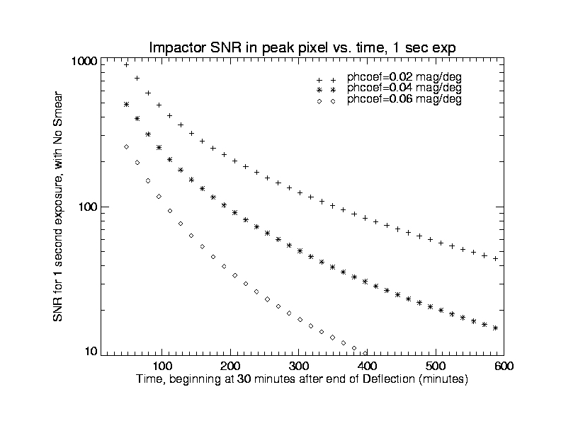
Figure 8 SNR of the Impactor s/c as observed with the HRI

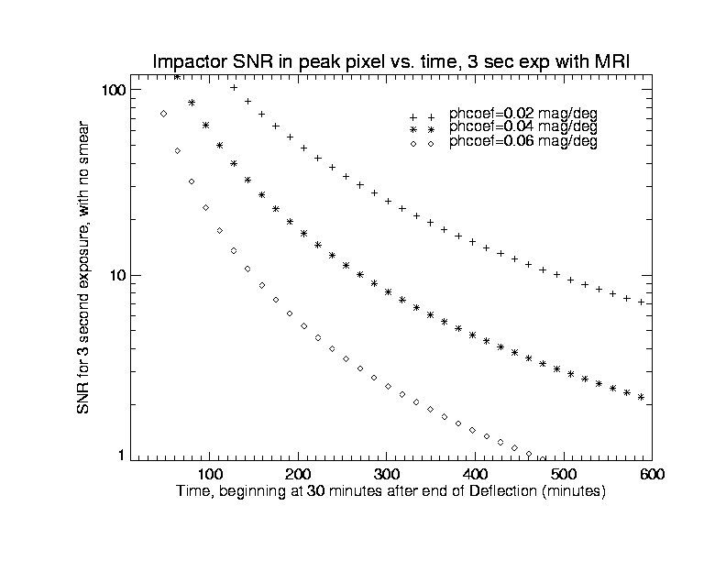
Figure 9 SNR of the Impactor s/c as observed with the MRI

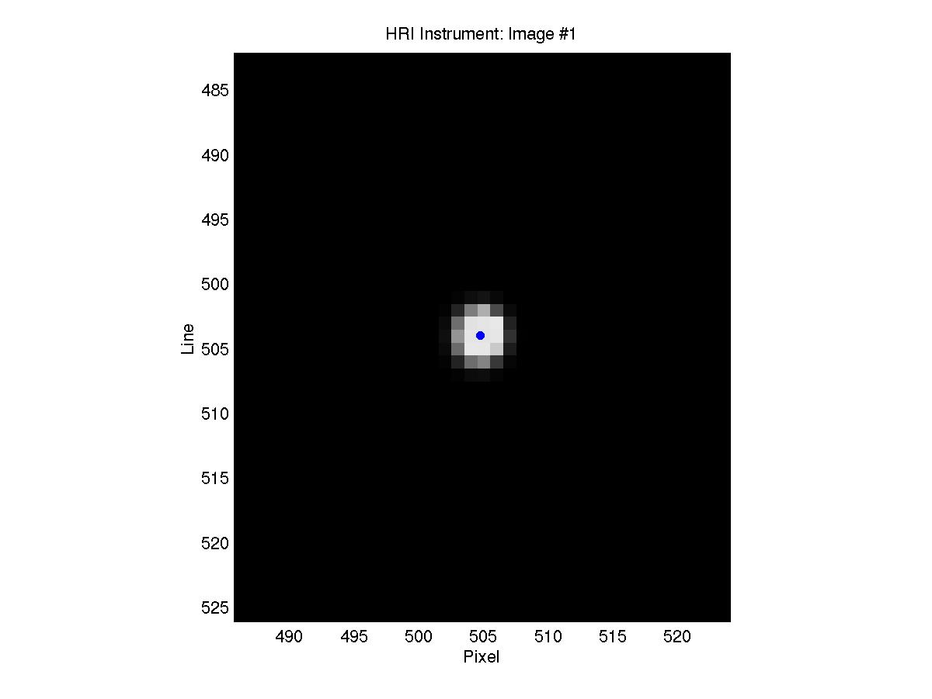

Figure 10 Simulated subframe image of the Impactor s/c in the HRI at a range of 179.9 km and phase of ~ 65°; blue dot represents location of CB

SIMULATIONS AND MONTE CARLO BASED PERFORMANCE ANALYSIS

Given that sufficient optical signal from the Impactor s/c is expected, as shown in the previous section, a suite of MATLAB algorithms have been developed to:

- Simulate images of the Impactor s/c using either the MRI or HRI instrument
- Integrate the Impactor and Flyby s/c truth trajectories
- Perform image processing and orbit determination⁶
- Evaluate the Flyby position error (true position – estimated position) at the key science epochs (TOI and TOFI)
- Compute the pointing error at TOI and TOFI
- Perform a Monte Carlo analysis to assess the pointing error due to the uncertainty in the impact site location at the key science epochs

The random parameters in the Monte Carlo simulations are the Flyby trajectory deflection maneuver errors, and the center-finding errors described previously (0.1 – 0.2 pixels; 1 – 2 μrad for the MRI). The epoch time is taken to be Release plus 35 minutes (start OpNav imaging arc) which results in a range of ~ 180 km from the Flyby s/c to the Impactor s/c. The deflection burn is modeled as an impulsive maneuver occurring at release plus 5 minutes, with maneuver execution errors randomly sampled in the alongtrack direction (0.50 m/s, 1σ), relative to comet Tempel 1, and crosstrack directions (0.12 m/s, 1σ). These errors represent the expected flight system deflection maneuver execution capability and are used to integrate the Flyby s/c truth trajectory.

The beginning of Impactor image acquisition occurs at Release plus 35 minutes and ends at Release plus 1 hour and 35 minutes to give a batch orbit determination (OD) arc length of 1 hour. Images are sampled at a 15 min interval providing 5 observations that are used in the estimation process. At the beginning of image acquisition, differences between the Flyby s/c’s true position and the Flyby s/c’s expected position result in pointing errors on the order of 3.8 mrad (3σ). Here, the position error (3σ) results in a pointing error that is approximately 2 times larger than the HRI FOV. Since immediate detection of the Impactor is not guaranteed with the HRI, it will be preferable to use the MRI throughout. In 500 simulation runs, the uncertainty in the initial position of the Impactor never exceeded the MRI FOV. The maximum pointing error was found to be 6.5 mrad at initial image acquisition. The maximum dispersion from the MRI boresight was found to be 650.5 pixels or approximate 6.5 mrads in 500 simulation runs. Figure 11 shows the dispersion of locations of the Impactor in the MRI FOV at initial acquisition. The HRI FOV is superimposed (blue) and shows that the associated Flyby s/c maneuver execution errors require use of the MRI instrument for Impactor tracking to be assured of capturing the Impactor observations.

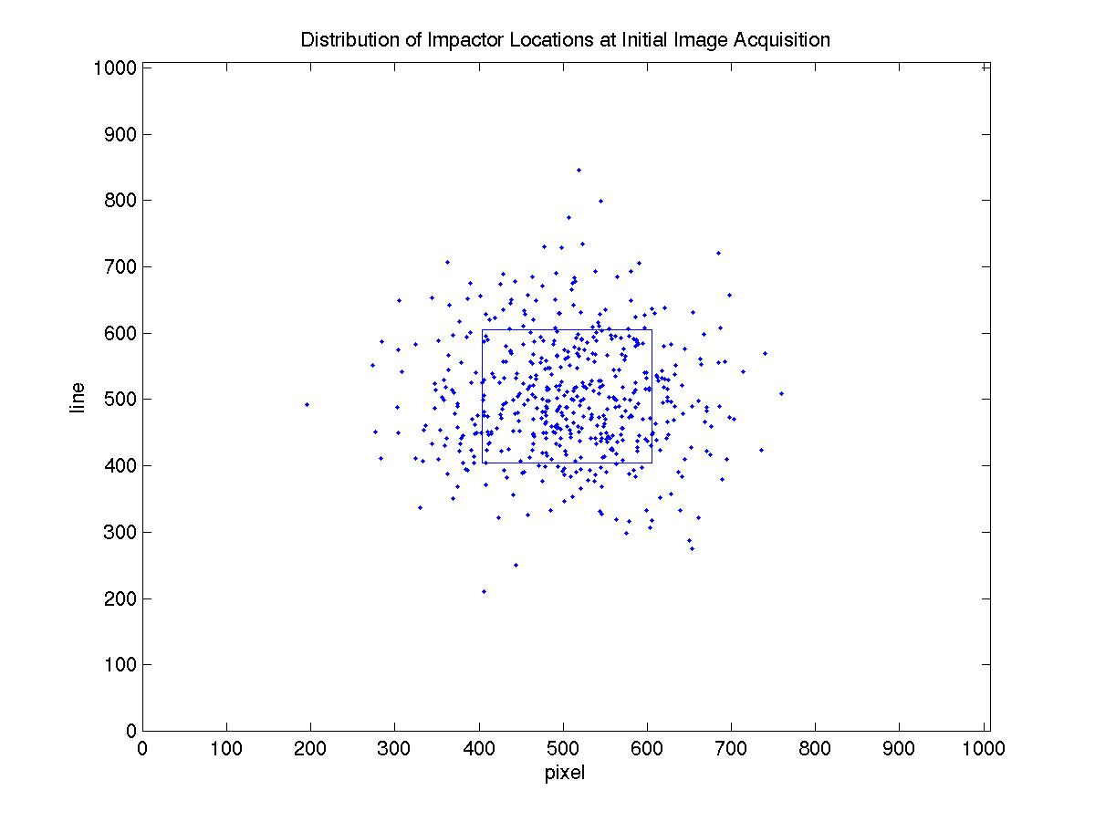
Figure 11 Dispersion of Impactor locations in the MRI FOV at initial image acquisition (Release + 35 min) for 500 simulation runs; the HRI FOV is superimposed in blue

After computing the orbit solution, the estimated Flyby position is evaluated at TOI (Release + 24 hrs). The angular difference between the unit direction vectors from the true Flyby s/c position and estimated Flyby position, relative to the Impactor s/c gives the pointing error at TOI.
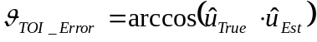

where
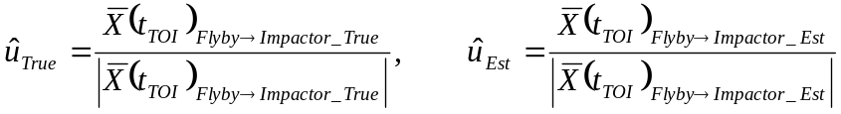

Here,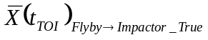 and 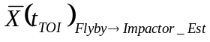 are the true and estimated position of the Flyby s/c, relative to the Impactor s/c at TOI, respectively.

At TOFI (TOI + 750 sec) the pointing error is computed differently, since there is a discontinuity in the Impactor’s trajectory at that time. Following impact, the B-plane error vector, 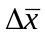, remains constant and represents that contribution to the pointing error, which is due to the uncertainty in our knowledge of where the impact site is located. Here we compute the B-plane error vector by first transforming the vector difference between the Flyby s/c’s estimated position and the Flyby s/c’s true position relative to the Impactor s/c at TOI into the B-plane reference frame.

The error vector is then the projection of 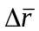 onto the B-plane to give the direction. The projection is scaled by the range and pointing error at TOI to give the magnitude.

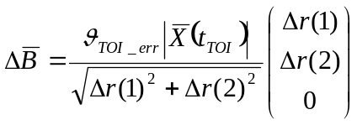

Transforming the projection into the ICRF frame gives the inertial correction vector that is used to evaluate the pointing error at TOFI.

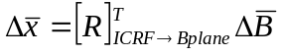

Using the error vector and the true Flyby s/c range to the comet nucleus at TOFI, the pointing error is computed from the law of cosines as

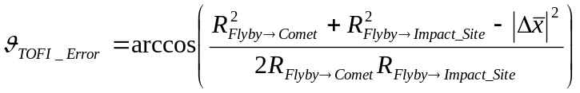

where

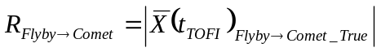

and
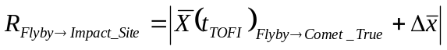

Table 2 shows the error contribution of the uncertainty in the impact site location to the overall pointing error at TOI and TOFI. The OD arclength is 1 hr with observations taken every 15 min to give a total of 5 optical navigation (OpNav) observations. The following section will describe the autonomous algorithm that is necessary to point the MRI and HRI instruments at the key science epochs using the estimated Flyby s/c’s trajectory.

Table 2
Monte Carlo results for Flyby s/c pointing error contribution due to impact site location uncertainty at TOI and TOFI based on 500 simulation runs

Key Science Epoch | Min  (μrad) | Max  (μrad) | 3*RMS Error  (μrad)
TOI Pointing | 3.47 | 41.2 | 72.3
TOFI Pointing  (TCA-100 sec) | 21.3 | 328 | 441

POINTING ERROR SENSITIVITY TO OPNAV ORBIT DETERMINATION

For this approach, pointing errors depend directly upon the accuracy of the orbit determination process using optical images of the Impactor s/c. To fully understand the problem and to assess the best approach, we consider the sensitivity to OD arc length, center-finding errors, and range from the Flyby s/c to the Impactor s/c during the OpNav imaging arc.

To assess the sensitivity to the OD arc length, 3 different OD batch lengths were considered. Each batch has the same starting epoch corresponding to release (R) + 35 min and the same imaging interval of 1 image per 15 min. Table 3 shows the results for 1 hr, 2 hr, and 3 hr OD batch solutions.

Table 3
Sensitivity to OD Arc Length

OD Arc Length  Number of Observations | RMS  TOI Pointing Error (μrad) | RMS  TOFI Pointing Error (μrad)
1 hr arc ⇒ 5 OpNavs  500 sim runs | 24.1 | 147
2 hr arc ⇒ 9 OpNavs  100 sim runs | 45.8 | 297
3 hr arc ⇒ 13 OpNavs  100 sim runs | 37.5 | 231

This analysis assumes center-finding errors of 0.1-0.2 pixels, which represents a random angular measurement error of 1-2 μrad (1σ) in the MRI instrument. Using the HRI, this error would be 0.2-0.4 μrad. Here, we considered a single 1 hr OD batch arc length starting at R + 35 minutes with 1 observation every 15 min. Table 4 shows the results for 3 different center-finding uncertainties: 2 μrad (0.2 MRI pixels), 10 μrad (1 MRI pixel), and 20 μrad (2 MRI pixels).

Table 4
Sensitivity to center-finding errors

Center-finding Error  (1σ) | RMS  TOI Pointing Error (μrad) | RMS  TOFI Pointing Error (μrad)
2 μrad  (0.2 MRI pixels)  500 sim runs | 24.1 | 147
10 μrad  (1 MRI pixel)  100 sim runs | 47.0 | 289
20 μrad  (2 MRI pixels)  100 sim runs | 88.2 | 547

Finally, the sensitivity to the Impactor range during OpNav imaging was considered. Three different 1 hr OD arcs were considered: the first batch started at R + 35 min and ended 1 hr later; the second batch started at R + 1 hr 35 min and ended 1 hr later (R + 2 hr 35 min); and the third batch started at R + 2 hr 35 min and ended at 3 hr 35 min. Table 5 shows the RMS pointing errors at TOI and TOFI for each of the 3 OD arcs. The degradation with range is not unexpected since the OD process relies on angular measurements whose spatial error increases as the range increases.

Table 5
Sensitivity to Impactor range during OpNav imaging

OD Arc Start | OD Arc End | RMS  TOI Pointing Error (μrad) | RMS  TOFI Pointing Error (μrad)
R + 35 min  500 sim runs | R + 1 hr 35 min | 24.1 | 147
R + 1 hr 35 min  100 sim runs | R + 2 hr 35 min | 28.7 | 176
R + 2 hr 35 min  100 sim runs | R + 3 hr 35 min | 29.0 | 178

THE AUTONOMOUS POINTING CORRECTION ALGORITHM

Until now we have discussed the process of ground-based OpNav to determined the location of the Impactor s/c relative to the Flyby s/c and the uncertainty in the location of the impact site, which results in pointing errors at the key science epochs. The next step is to develop an algorithm for computing a pointing correction on-board the Flyby s/c and in real time so that the ADCS software can adjust the MRI/HRI pointing during encounter.

Once the Flyby s/c’s inertial, heliocentric trajectory has been determined based on optical observations of the Impactor s/c, the Chebyshev coefficients that represent the Flyby s/c and the Chebyshev coefficients that represent the Impactor s/c trajectory as a function of time throughout the entire encounter period, are uploaded to the AutoNav flight software on the Flyby s/c. As shown in figure 2, AutoNav acquires and processes images of comet Tempel 1 starting 2 hrs prior to the expected TOI. Every minute, AutoNav updates its position and velocity based on observations of the CB of comet Tempel 1 and generates an ephemeris in the form of Chebyshev coefficients. These coefficients are passed to the ADCS software, which evaluates the position of the Flyby s/c and the position of Tempel 1 (also from a set of Chebyshev coefficients) and computes the desired pointing direction to center the comet CB in the HRI FOV. With every AutoNav OD update, the difference between the Flyby s/c’s ground-based inertial position (based on optical observations of the Impactor s/c) and AutoNav’s updated estimate of the Flyby s/c’s inertial position (based on optical observations of Tempel 1) is computed and the resulting vector is applied directly to correct the Impactor’s heliocentric position as shown in figure 12.
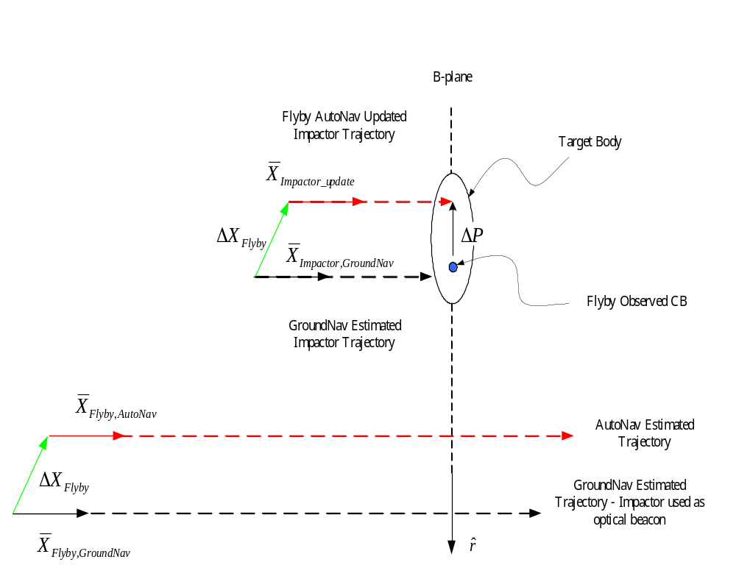

Figure 12 Graphical depiction of the inertial pointing correction, ΔP, which is computed by AutoNav. All state vectors correspond to the same AutoNav OD update epoch time (i.e. 5 min prior to estimated TOI); B-plane is normal to view

The difference between the Flyby s/c AutoNav solution (based on images of the comet) relative to the inertial frame and the Flyby s/c GroundNav solution (based on images of the Impactor s/c) relative to the inertial frame is computed to be

This correction is applied directly to the Impactor s/c’s inertial state obtained by evaluating the Impactor s/c ephemeris, which resides on-board the Flyby s/c in the form of Chebyshev coefficients, at 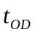

The updated Impactor s/c state is then mapped into B-plane coordinates, where 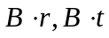 give the 2-D pointing correction (the impact location), relative to the observed CB, in the B-plane frame. Since the orientation of the B-plane is known relative to the ICRF, the 2-D vector, 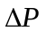, is transformed into an inertial 3-D pointing correction via the transpose of 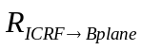 and passed to ADCS for application.

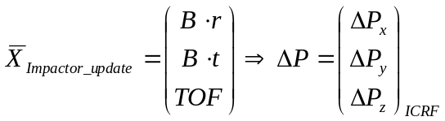

The process of computing the pointing correction occurs with every OD update until TOI after which time the applied correction will remain constant.

SUMMARY

Predicting the impact location to point the Flyby s/c instruments in the presence of an inactive Impactor s/c can be achieved by treating the Impactor s/c as an optical beacon, estimating the Flyby s/c’s inertial trajectory using images of the Impactor, uploading the estimated trajectory to the Flyby s/c’s AutoNav software and autonomously computing a pointing correction for ADCS. This correction addresses only that component of the overall pointing error at key science epochs (TOI and TOFI), which is due to the uncertainty in the impact site location for an inactive Impactor s/c. Simulations show that uncertainties in the Flyby’s position relative to the Impactor at the time of initial image acquisition require use of the MRI instrument for Impactor optical navigation purposes and acquisition of OpNav images as soon as possible following release of the Impactor s/c provide the best measurements. Results also show that for an inactive Impactor s/c, the pointing error due to impact site location uncertainty is driven back down to a level comparable with that of the baseline approach of a maneuvering Impactor s/c that will target the nucleus center of brightness. By treating the Impactor as an optical beacon pointing errors improve from 519 μrad to 72.3 μrad (3σ) at TOI, and from 3.96 mrad to 441 μrad (3σ) at TOFI; this is the difference between a mission with seriously degraded science return and a mission with flight system performance that equals the current baseline approach, provided that the inactive Impactor impacts in an illuminated area. The maneuvering Impactor design was selected to first, improve the probability of impacting in an illuminated area and second, impacting in a location, which is viewable from the Flyby s/c.

AKNOWLEDGEMENTS

The authors would like to acknowledge Bob Gaskell, NASA-Jet Propulsion Laboratory, for his work on modeling cometary nuclei for simulation analysis and for providing us with a sphere model of the Impactor s/c and Robert Werner, NASA-Jet Propulsion Laboratory for his comments and suggestions. The research described in this paper was carried out at the Jet Propulsion Laboratory, California Institute of Technology, under contract with the National Aeronautics and Space Administration.

REFERENCES

- Bhaskaran, S., Riedel, J. E., Synnott, S. P. (1996) “Autonomous Optical Navigation for Interplanetary Missions.” Space Sciencecraft Control and Tracking in the New Mellennium, Proc. SPIE, pp. 32-34.

- Bank, T., Frazier, W., Blume, W., Kubitschek, D., Mastrodemos, N., Null, G., and Synnott, S. (2001) “Deep Impact: 19 Gigajoules Can Make Quite An Impression.” 24th Annual AAS Guidance and Control Conference, Breckenridge, CO.

- Mastrodemos, N. (2002) “Rationale for High Rate of Optical Data Acquisition During Approach Phase.” JPL Interoffice Memorandum DI/2002-2.

- Phinney, A. (2001) “Mass on the Impactor.” BATC Systems Engineering Report DI-IMP-STR-004.

- Fernandez, Y.A., et al. (2000) “Physical Properties of the Nucleus of Comet 2P/Encke.” Icarus, 147, pp. 145-160.

- Bhaskaran, S., et al. (1998) “Orbit Determination Performance Evaluation of the Deep Space 1 Autonomous Navigation Software.” AAS/AIAA Space Flight Mechanics Meeting, Monterey, CA.

